**Main Operation**

In this part, main operation of flyback converter is explained. Figure 2 shows the basic flyback configuration.

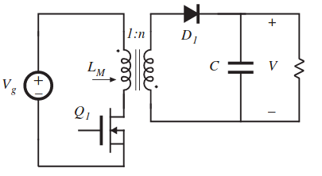

Figure 2: Circuit Schematic of the Flyback Converter

Flyback converters are derived from the buck-boost converter. Operation of flyback converter can be investigated according to two states which are switch ON and switch OFF period.

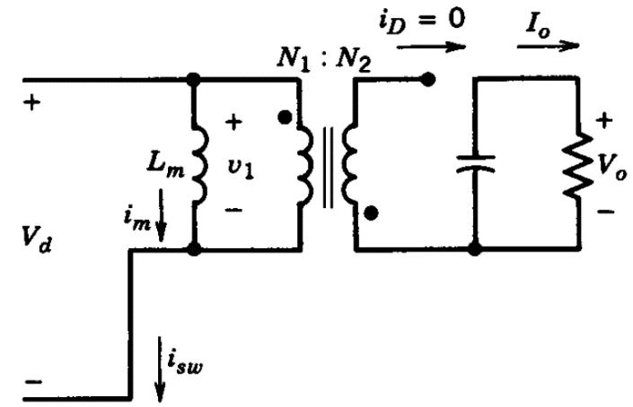

Figure 3: Approximate Circuit Schematic of Flyback during Switch is ON

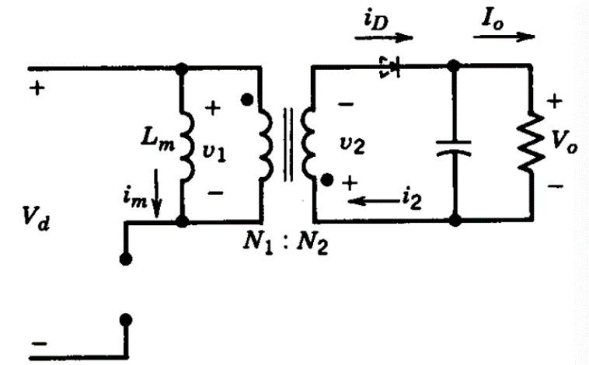

Figure 4: Approximate Circuit Schematic of Flyback during Switch is OFF

Figure 3 shows the circuit schematic of the flyback converter during switch is ON period and Figure 4 shows the circuit schematic of the flyback during switch is OFF period.

When the switch is ON, due to winding polarities, the diode will be reversed biased. The continuous-current-conduction mode in buck-boost converter corresponds to an incomplete demagnetization of the inductor core in the flyback converter. After the switch is turned off and the energy stored in the core causes the current to flow in the secondary winding through the diode.

Figure 5 shows the voltage on the magnetizing branch, core flux and the diode current of the flyback converter.

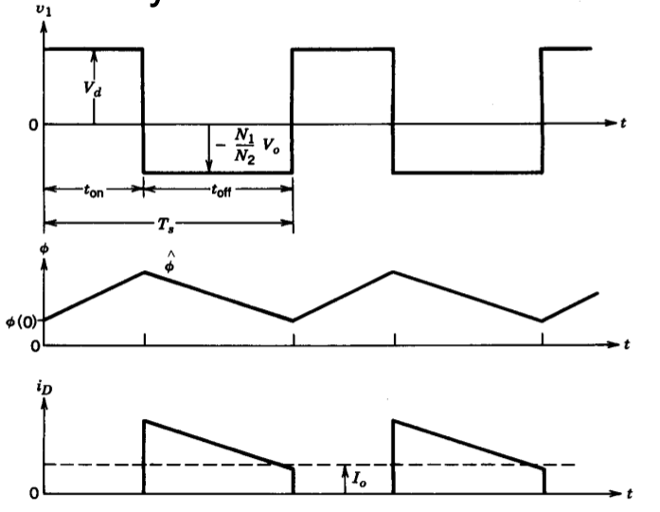

Figure 5: Voltage across the Magnetizing branch, core flux and the diode current

$$Φ\left(t\right)=Φ\left(0\right)+\frac{V_{d}}{N_{1}}t 0<t<t_{on}$$

$$Φ_{peak}=Φ\left(t_{on}\right)=Φ\left(0\right)+\frac{V_{d}}{N_{1}}t_{on}$$

$$Φ\left(t\right)=Φ\left(t_{on}\right)-\frac{V_{o}}{N_{2}}t t_{on}<t<T_{s}$$

and,

$$Φ\left(T_{s}\right)=Φ\left(t_{on}\right)-\frac{V_{o}}{N_{2}}\left(T_{s}-t_{on}\right)$$

$$=Φ\left(0\right)+\frac{V_{d}}{N_{1}}t_{on}-\frac{V_{o}}{N_{2}}(T_{s}-t_{on})$$

Since the periodic characteristic,

$$Φ\left(T_{s}\right)=Φ\left(0\right)$$

Therefore,

$$\frac{V_{o}}{V_{d}}=\frac{N_{2}}{N_{1}}*\frac{D}{\left(1-D\right)}$$